**VISVESVARAYA TECHNOLOGICAL UNIVERSITY**

"Jnana Sangama", Belagavi : 590018

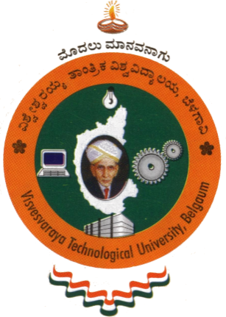

A Case Study Report on

**Smart Watch – Apple Series 7**

Submitted in partial fulfillment of the requirement for the award of the degree of

**Bachelor of Engineering**

**in**

**Computer Science and Engineering**

By

**ANISH KUMAR 1AY21CS028**

**BHUVAN GOWDA A R 1AY21CS042**

**DALAVAI HRUDAY 1AY21CS049**

**GAGAN ACHARYA G 1AY21CS056**

Under the guidance of

**Mr. Gururaj P**

Assistant Professor  
Dept. CS&E, AIT, Bengaluru

|  |  |
| --- | --- |
| |  | | --- | |  | |



**DEPARTMENT OF COMPUTER SCIENCE & ENGINEERING**

**ACHARYA INSTITUTE OF TECHNOLOGY**

(Affiliated to Visvesvaraya Technological University, Belgaum)

**2024-2025**